Native American Students, Parents, Guardians, Educators, Staff and Community!

https://lh6.googleusercontent.com/bW9hth_Xx0LCaSDqS4_gTk1peLWjZQ_WGq8ppsNKfeseIXn-WDpsdEpFHe9H_aK_NIYmwalfaKsfNy-Hk2HtARiya4KHUNCxSSwIf_H7TLxlqZtU9A3PpNl0510WSQK6ZTFyqj4VPlease scan to join

Native American Education Scotland County Schools Facebook page!

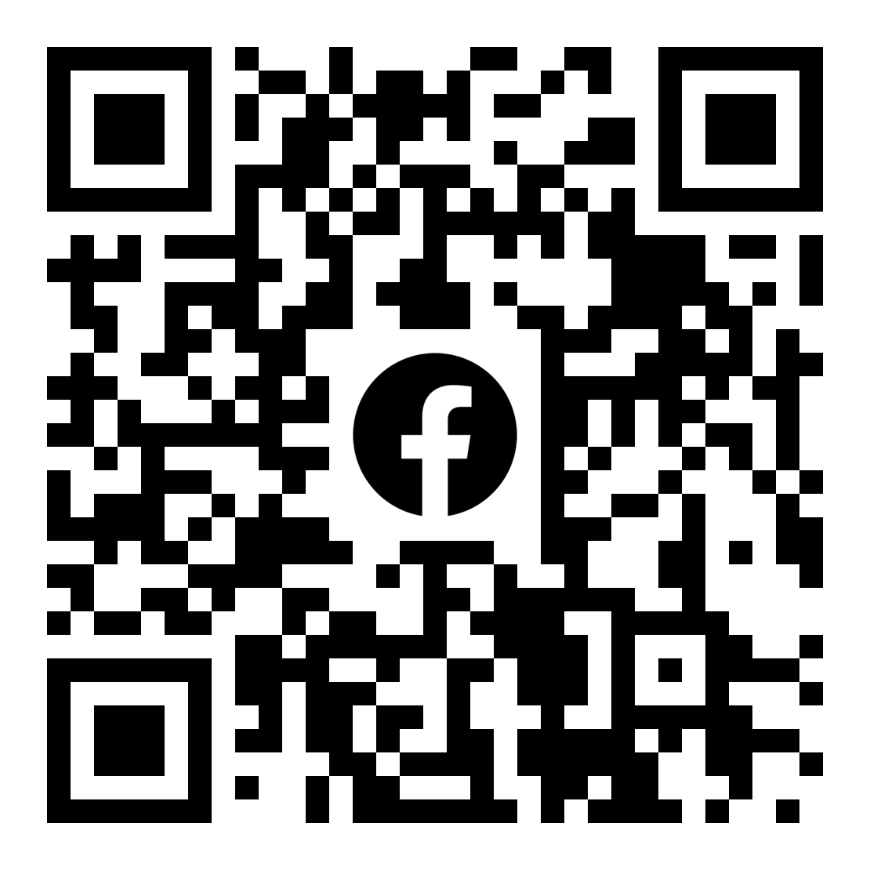

https://lh6.googleusercontent.com/bW9hth_Xx0LCaSDqS4_gTk1peLWjZQ_WGq8ppsNKfeseIXn-WDpsdEpFHe9H_aK_NIYmwalfaKsfNy-Hk2HtARiya4KHUNCxSSwIf_H7TLxlqZtU9A3PpNl0510WSQK6ZTFyqj4V